NAME: menahil Zaheer

CMS ID: 502881

Faculty of Computing

CS-272 Artificial Intelligence
BSAI-1 A

Lab 1: Introduction to Python
CLO 4

Date: 09-09-2025

Lab Engineer: Mr Hafiz Arslan Ramzan
Instructor: Dr Seemab Latif

Lab 1: Introduction to Python
Introduction
The purpose of this lab is to get familiar with Python programming language.

Tools/Software Requirement
- Python 3.11, Anaconda and Jupyter notebook (preferable)

Python Basics

Table of Contents

- Invoking the Interpreter
- Operators
- Strings
- Dir and Help
- Built-in Data Structures
  - Lists
  - Tuples
  - Sets
  - Dictionaries
- Writing Scripts
- Indentation
- Tabs vs Spaces
- Writing Functions
- Object Basics
  - Defining Classes
  - Using Objects
  - Static vs Instance Variables
- Tips and Tricks
- Troubleshooting
- More References

The programming assignments in this course will in Python, an interpreted, object- oriented language that shares some features with both Java and Scheme. This tutorial will walk through the primary syntactic constructions in Python, using short examples.

We encourage you to type all python code shown in the tutorial onto your own machine. Make sure it responds the same way.

You may find the Troubleshooting section helpful if you run into problems. It contains a list of the frequent problems previous students have encountered when following this tutorial.

Invoking the Interpreter

Python can be run in one of two modes. It can either be used interactively, via an interpreter, or it can be called from the command line to execute a script. We will first use the Python interpreter interactively.

You invoke the interpreter by entering python at the command prompt.
Note: you may have to type python3.11 or python3.10 rather than python, depending on your machine.

Operators

The Python interpreter can be used to evaluate expressions, for example simple arithmetic expressions. If you enter such expressions at the prompt (>>>) they will be evaluated, and the result will be returned on the next line.

>>> 1 + 1
2
>>> 2 * 3
6

Boolean operators also exist in Python to manipulate the primitive True and False values.

>>> 1==0
False
>>> not (1==0)
True
>>> (2==2) and (2==3)
False
>>> (2==2) or (2==3)
True

Strings

Like Java, Python has a built-in string type. The + operator is overloaded to do string concatenation on string values.

>>> 'Machine' + "Learning" 'MachineLearning'

There are many built-in methods which allow you to manipulate strings.

>>> 'machine'.upper() 'MACHINE'
>>> 'HELP'.lower()
'help'
>>> len('Help') 4

Notice that we can use either single quotes ' ' or double quotes " " to surround string. This allows for easy nesting of strings.

We can also store expressions into variables.

>>> s = 'hello world'
>>> print s hello world
>>> s.upper() 'HELLO WORLD'
>>> len(s.upper()) 11
>>> num = 8.0
>>> num += 2.5
>>> print num 10.5

In Python, you do not have declare variables before you assign to them.

Exercise: Dir and Help

Learn about the methods Python provides for strings. To see what methods Python provides for a datatype, use the dir and help commands:

>>> s = 'abc'

>>> dir(s)
[' add ', ' class ', ' contains ', ' delattr ', ' doc ', ' eq ', ' ge ', ' getattribute ', ' getitem ', ' getnewargs ',
' getslice ', ' gt ', ' hash ', ' init ',' le ', ' len ',
' lt ', ' mod ', ' mul ', ' ne ', ' new ', ' reduce ',

- reduce_ex ',' repr ', ' rmod ', ' rmul ', ' setattr ', ' str ', 'capitalize', 'center', 'count', 'decode', 'encode', 'endswith',
'expandtabs', 'find', 'index', 'isalnum', 'isalpha', 'isdigit', 'islower',
'isspace', 'istitle', 'isupper', 'join', 'ljust', 'lower', 'lstrip',
'replace', 'rfind','rindex', 'rjust', 'rsplit', 'rstrip', 'split', 'splitlines', 'startswith', 'strip', 'swapcase', 'title', 'translate', 'upper', 'zfill']

>>> help(s.find)

Help on built-in function find:

find(...)
S.find(sub [,start [,end]]) -> int

Return the lowest index in S where substring sub is found, such that sub is contained within s[start,end]. Optional arguments start and end are interpreted as in slice notation.

Return -1 on failure.

>> s.find('b') 1

Try out some of the string functions listed in dir (ignore those with underscores '_' around the method name).

Built-in Data Structures

Python comes equipped with some useful built-in data structures, broadly like Java's collections package.

Lists

Lists store a sequence of mutable items:

>>> fruits = ['apple','orange','pear','banana']
>>> fruits[0] 'apple'

We can use the + operator to do list concatenation:

>>> otherFruits = ['kiwi','strawberry']
>>> fruits + otherFruits
>>> ['apple', 'orange', 'pear', 'banana', 'kiwi', 'strawberry']

Python also allows negative indexing from the back of the list. For instance, fruits[-1] will access the last element 'banana':

>>> fruits[-2] 'pear'
>>> fruits.pop() 'banana'
>>> fruits
['apple', 'orange', 'pear']
>>> fruits.append('grapefruit')
>>> fruits
['apple', 'orange', 'pear', 'grapefruit']
>>> fruits[-1] = 'pineapple'
>>> fruits
['apple', 'orange', 'pear', 'pineapple']

We can also index multiple adjacent elements using the slice operator. For instance, fruits[1:3], returns a list containing the elements at position 1 and 2. In general fruits[start:stop] will get the elements in start, start+1, ..., stop-1. We can also do fruits[start:] which returns all elements starting from the start index. Also fruits[:end] will return all elements before the element at position end:

>>> fruits[0:2] ['apple', 'orange']
>>> fruits[:3]
['apple', 'orange', 'pear']
>>> fruits[2:] ['pear', 'pineapple']
>>> len(fruits) 4

The items stored in lists can be any Python data type. So, for instance we can have lists of lists:

>>> lstOfLsts = [['a','b','c'],[1,2,3],['one','two','three']]
>>> lstOfLsts[1][2] 3
>>> lstOfLsts[0].pop() 'c'
>>> lstOfLsts
[['a', 'b'],[1, 2, 3],['one', 'two', 'three']]

Exercise: Lists

Play with some of the list functions. You can find the methods you can call on an object via the
dir and get information about them via the help command:

>>> dir(list)
[' add ', ' class ', ' contains ', ' delattr ', ' delitem ', ' delslice ', ' doc ', ' eq ', ' ge ', ' getattribute ',

- getitem ', ' getslice ', ' gt ', ' hash ', ' iadd ', ' imul ',
' init ', ' iter ', ' le ', ' len ', ' lt ', ' mul ', ' ne ', ' new ', ' reduce ', ' reduce_ex ', ' repr ', ' reversed ',
- rmul ', ' setattr ', ' setitem ', ' setslice ', ' str ', 'append', 'count', 'extend', 'index', 'insert', 'pop', 'remove', 'reverse', 'sort']

>>> help(list.reverse)
Help on built-in function reverse:

reverse(...)
L.reverse() -- reverse *IN PLACE*

>>> lst = ['a','b','c']
>>> lst.reverse()
>>> ['c','b','a']

Note: Ignore functions with underscores "_" around the names; these are private helper methods. Press 'q' to back out of a help screen.

Tuples

A data structure similar to the list is the tuple, which is like a list except that it is immutable once it is created (i.e. you cannot change its content once created). Note that tuples are surrounded with parentheses while lists have square brackets.

>>> pair = (3,5)
>>> pair[0] 3
>>> x,y = pair
>>> x 3
>>> y 5
>>> pair[1] = 6
TypeError: object does not support item assignment

The attempt to modify an immutable structure raised an exception. Exceptions indicate errors: index out of bounds errors, type errors, and so on will all report exceptions in this way.

Sets

A set is another data structure that serves as an unordered list with no duplicate items. Below, we show how to create a set, add things to the set, test if an item is in the set, and perform common set operations (difference, intersection, union):

>>> shapes = ['circle','square','triangle','circle']
>>> setOfShapes = set(shapes)
>>> setOfShapes set(['circle','square','triangle'])
>>> setOfShapes.add('polygon')
>>> setOfShapes set(['circle','square','triangle','polygon'])
>>> 'circle' in setOfShapes True
>>> 'rhombus' in setOfShapes False
>>> favoriteShapes = ['circle','triangle','hexagon']
>>> setOfFavoriteShapes = set(favoriteShapes)
>>> setOfShapes - setOfFavoriteShapes set(['square','polyon'])
>>> setOfShapes & setOfFavoriteShapes set(['circle','triangle'])
>>> setOfShapes | setOfFavoriteShapes set(['circle','square','triangle','polygon','hexagon'])

Note that the objects in the set are unordered; you cannot assume that their traversal or print order will be the same across machines!

Dictionaries

The last built-in data structure is the dictionary which stores a map from one type of object (the key) to another (the value). The key must be an immutable type (string, number, or tuple). The value can be any Python data type.

Note: In the example below, the printed order of the keys returned by Python could be different than shown below. The reason is that unlike lists which have a fixed ordering, a dictionary is simply a hash table for which there is no fixed ordering of the keys (like HashMaps in Java). The order of the keys depends on how exactly the hashing algorithm maps keys to buckets, and will usually seem arbitrary. Your code should not rely on key ordering, and you should not be surprised if even a small modification to how your code uses a dictionary results in a new key ordering.

>>> studentIds = {'knuth': 42.0, 'turing': 56.0, 'nash': 92.0 }
>>> studentIds['turing'] 56.0
>>> studentIds['nash'] = 'ninety-two'
>>> studentIds
{'knuth': 42.0, 'turing': 56.0, 'nash': 'ninety-two'}
>>> del studentIds['knuth']
>>> studentIds
{'turing': 56.0, 'nash': 'ninety-two'}
>>> studentIds['knuth'] = [42.0,'forty-two']
>>> studentIds
{'knuth': [42.0, 'forty-two'], 'turing': 56.0, 'nash': 'ninety-two'}
>>> studentIds.keys()

['knuth', 'turing', 'nash']
>>> studentIds.values()
[[42.0, 'forty-two'], 56.0, 'ninety-two']
>>> studentIds.items()
[('knuth',[42.0, 'forty-two']), ('turing',56.0), ('nash','ninety-two')]
>>> len(studentIds) 3

As with nested lists, you can also create dictionaries of dictionaries.

Exercise: Dictionaries

Use dir and help to learn about the functions you can call on dictionaries.

Writing Scripts

Now that you've got a handle on using Python interactively, let's write a simple Python script that demonstrates Python's for loop. Open the file called foreach.py and update it with the following code:

# This is what a comment looks like
fruits = ['apples','oranges','pears','bananas'] for fruit in fruits:
print fruit + ' for sale'

fruitPrices = {'apples': 2.00, 'oranges': 1.50, 'pears': 1.75} for fruit, price in fruitPrices.items():
if price < 2.00:
print '%s cost %f a pound' % (fruit, price) else:
print fruit + ' are too expensive!'

At the command line, use the following command in the directory containing foreach.py: [cs188-ta@nova ~/tutorial]$ python foreach.py
apples for sale oranges for sale pears for sale bananas for sale
oranges cost 1.500000 a pound pears cost 1.750000 a pound apples are too expensive!

Remember that the print statements listing the costs may be in a different order on your screen than in this tutorial; that's since we're looping over dictionary keys, which are unordered. To learn more about control structures (e.g., if and else) in Python, check out the official Python tutorial section on this topic.

If you like functional programming, you might also like map and filter:

>>> map(lambda x: x * x, [1,2,3]) [1, 4, 9]
>>> filter(lambda x: x > 3, [1,2,3,4,5,4,3,2,1]) [4, 5, 4]

You can learn more about lambda if you're interested.

The next snippet of code demonstrates Python's list comprehension construction:

nums = [1,2,3,4,5,6]
plusOneNums = [x+1 for x in nums]
oddNums = [x for x in nums if x % 2 == 1] print oddNums
oddNumsPlusOne = [x+1 for x in nums if x % 2 ==1] print oddNumsPlusOne

This code is in a file called listcomp.py, which you can run:

[cs188-ta@nova ~]$ python listcomp.py [1,3,5]
[2,4,6]

Exercise: List Comprehensions

Write a list comprehension which, from a list, generates a lowercased version of each string that has length greater than five. You can find the solution in listcomp2.py.

Beware of Indentation!

Unlike many other languages, Python uses the indentation in the source code for interpretation. So for instance, for the following script:

if 0 == 1:
print 'We are in a world of arithmetic pain' print 'Thank you for playing'

will output

Thank you for playing

But if we had written the script as

if 0 == 1:

print 'We are in a world of arithmetic pain' print 'Thank you for playing'

there would be no output. The moral of the story: be careful how you indent! It's best to use four spaces for indentation -- that's what the course code uses.

Tabs vs Spaces

Because Python uses indentation for code evaluation, it needs to keep track of the level of indentation across code blocks. This means that if your Python file switches from using tabs as indentation to spaces as indentation, the Python interpreter will not be able to resolve the ambiguity of the indentation level and throw an exception. Even though the code can be lined up visually in your text editor, Python "sees" a change in indentation and most likely will throw an exception (or rarely, produce unexpected behavior).

This most commonly happens when opening up a Python file that uses an indentation scheme that is opposite from what your text editor uses (aka, your text editor uses spaces and the file uses tabs). When you write new lines in a code block, there will be a mix of tabs and spaces, even though the whitespace is aligned. For a longer discussion on tabs vs spaces, see this discussion on StackOverflow.

Writing Functions

As in Java, in Python you can define your own functions:
fruitPrices = {'apples':2.00, 'oranges': 1.50, 'pears': 1.75} def buyFruit(fruit, numPounds):
if fruit not in fruitPrices:
print "Sorry we don't have %s" % (fruit) else:
cost = fruitPrices[fruit] * numPounds print "That'll be %f please" % (cost)

# Main Function
if name == ' main ': buyFruit('apples',2.4) buyFruit('coconuts',2)

Rather than having a main function as in Java, the name == ' main ' check is used to delimit expressions which are executed when the file is called as a script from the command line. The code after the main check is thus the same sort of code you would put in a main function in Java.

Save this script as fruit.py and run it:

[cs188-ta@nova ~]$ python fruit.py That'll be 4.800000 please
Sorry we don't have coconuts

Object Basics

Although this isn't a class in object-oriented programming, you'll have to use some objects in the programming projects, and so it's worth covering the basics of objects in Python. An object encapsulates data and provides functions for interacting with that data.

Defining Classes

Here's an example of defining a class named FruitShop: class FruitShop:
def init (self, name, fruitPrices): """
name: Name of the fruit shop

"""
fruitPrices: Dictionary with keys as fruit strings and prices for values e.g.
{'apples':2.00, 'oranges': 1.50, 'pears': 1.75}

self.fruitPrices = fruitPrices self.name = name
print 'Welcome to the %s fruit shop' % (name)

def getCostPerPound(self, fruit): """
fruit: Fruit string
Returns cost of 'fruit', assuming 'fruit' is in our inventory or None otherwise """
if fruit not in self.fruitPrices:
print "Sorry we don't have %s" % (fruit) return None
return self.fruitPrices[fruit]

def getPriceOfOrder(self, orderList): """
orderList: List of (fruit, numPounds) tuples

Returns cost of orderList. If any of the fruit are """
totalCost = 0.0
for fruit, numPounds in orderList: costPerPound = self.getCostPerPound(fruit)

if costPerPound != None:
totalCost += numPounds * costPerPound return totalCost

def getName(self): return self.name

The FruitShop class has some data, the name of the shop and the prices per pound of some fruit, and it provides functions, or methods, on this data. What advantage is there to wrapping this data in a class?

  - Encapsulating the data prevents it from being altered or used inappropriately,
  - The abstraction that objects provide make it easier to write general-purpose code.

Using Objects

So how do we make an object and use it? Make sure you have the FruitShop implementation in shop.py. We then import the code from this file (making it accessible to other scripts) using import shop, since shop.py is the name of the file. Then, we can create FruitShop objects as follows:

import shop

shopName = 'the Berkeley Bowl'
fruitPrices = {'apples': 1.00, 'oranges': 1.50, 'pears': 1.75} berkeleyShop = shop.FruitShop(shopName, fruitPrices) applePrice = berkeleyShop.getCostPerPound('apples')
print applePrice
print('Apples cost $%.2f at %s.' % (applePrice, shopName))

otherName = 'the Stanford Mall'
otherFruitPrices = {'kiwis':6.00, 'apples': 4.50, 'peaches': 8.75} otherFruitShop = shop.FruitShop(otherName, otherFruitPrices) otherPrice = otherFruitShop.getCostPerPound('apples')
print otherPrice
print('Apples cost $%.2f at %s.' % (otherPrice, otherName)) print("My, that's expensive!")

This code is in shopTest.py; you can run it like this:

[cs188-ta@nova ~]$ python shopTest.py Welcome to the Berkeley Bowl fruit shop 1.0
Apples cost $1.00 at the Berkeley Bowl. Welcome to the Stanford Mall fruit shop

4.5
Apples cost $4.50 at the Stanford Mall. My, that's expensive!

So what just happended? The import shop statement told Python to load all of the functions and classes in shop.py. The line berkeleyShop = shop.FruitShop(shopName, fruitPrices) constructs an instance of the FruitShop class defined in shop.py, by calling the init function in that class. Note that we only passed two arguments in, while init seems to take three arguments: (self, name, fruitPrices). The reason for this is that all methods in a class have self as the first argument. The self variable's value is automatically set to the object itself; when calling a method, you only supply the remaining arguments. The self variable contains all the data (name and fruitPrices) for the current specific instance (similar to this in Java). The print statements use the substitution operator (described in the Python docs if you're curious).

Static vs Instance Variables

The following example illustrates how to use static and instance variables in Python. Create the person_class.py containing the following code:
class Person:
population = 0
def init (self, myAge): self.age = myAge Person.population += 1
def get_population(self): return Person.population
def get_age(self): return self.age

We first compile the script:

[cs188-ta@nova ~]$ python person_class.py

Now use the class as follows:

>>> import person_class
>>> p1 = person_class.Person(12)
>>> p1.get_population() 1
>>> p2 = person_class.Person(63)
>>> p1.get_population() 2
>>> p2.get_population() 2
>>> p1.get_age()

12
>>> p2.get_age() 63

In the code above, age is an instance variable and population is a static variable. population is shared by all instances of the Person class whereas each instance has its own age variable.

More Python Tips and Tricks

This tutorial has briefly touched on some major aspects of Python that will be relevant to the course. Here are some more useful tidbits:

  - Use range to generate a sequence of integers, useful for generating traditional indexed for
loops:
  - for index in range(3):
  - print lst[index]

  - After importing a file, if you edit a source file, the changes will not be immediately propagated in the interpreter. For this, use the reload command:

>>> reload(shop)

Troubleshooting

These are some problems (and their solutions) that new Python learners commonly encounter.

Problem:
ImportError: No module named py

Solution:
When using import, do not include the ".py" from the filename. For example, you should say: import shop
NOT: import shop.py

Problem:
NameError: name 'MY VARIABLE' is not defined Even after importing you may see this.

Solution:
To access a member of a module, you have to type MODULE NAME.MEMBER NAME, where MODULE NAME is the name of the .py file, and MEMBER NAME is the name of the variable (or function) you are trying to access.

Problem:
TypeError: 'dict' object is not callable

Solution:
Dictionary looks up are done using square brackets: [ and ]. NOT parenthesis: ( and ).

Problem:
ValueError: too many values to unpack

Solution:
Make sure the number of variables you are assigning in a for loop matches the number of elements in each item of the list. Similarly for working with tuples.

For example, if pair is a tuple of two elements (e.g. pair =('apple', 2.0)) then the following code would cause the "too many values to unpack error":

(a,b,c) = pair

Here is a problematic scenario involving a for loop:

pairList = [('apples', 2.00), ('oranges', 1.50), ('pears', 1.75)] for fruit, price, color in pairList:
print '%s fruit costs %f and is the color %s' % (fruit, price, color)

Problem:
AttributeError: 'list' object has no attribute 'length' (or something similar)

Solution:
Finding length of lists is done using len(NAME OF LIST).

Problem:
Changes to a file are not taking effect.

Solution:

    - Make sure you are saving all your files after any changes.
    - If you are editing a file in a window different from the one you are using to execute python, make sure you reload(YOUR_MODULE) to guarantee your changes are being reflected. reload works similarly to import.

More References

  - The place to go for more Python information: www.python.org
  - A good reference book: Learning Python (From the UCB campus, you can read the whole book online)

Lab Tasks
Task #1

Write down a python program which takes two strings as input and calculate the
Levenshtein/Edit distance between the two strings.

Explanation:-

Levenshtein/Edit distance gives us a measure of similarity between two strings/sequences. Going by formal definition it is minimum number of single character edits required to transform one string into another.
Single character edits include:-
- Insertion
- Deletion
- Substitution

Mathematically:-

Mathematically Levenshtein/Edit distance between two strings ‘a’ and ‘b’ is defined as:-
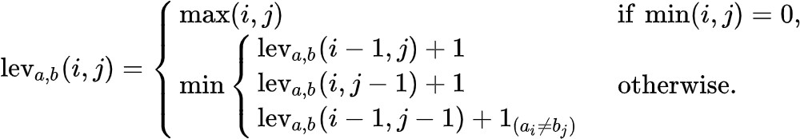

For further understanding of the formula you may read this blog as it explains it in great depth or you may get back to me wherever/whenever you stuck.
https://medium.com/@ethannam/understanding-the-levenshtein-distance-equation-for-beginners- c4285a5604f0

But it does not explain how to count the edit operations while calculating overall Levenshtein distance.
The output of your program should somewhat look like:-

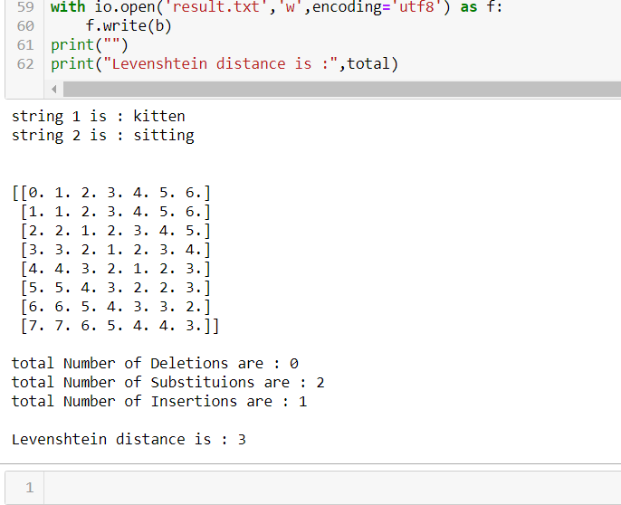

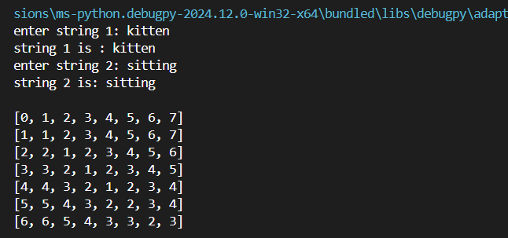
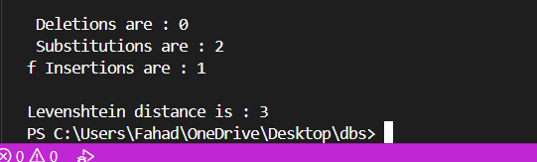
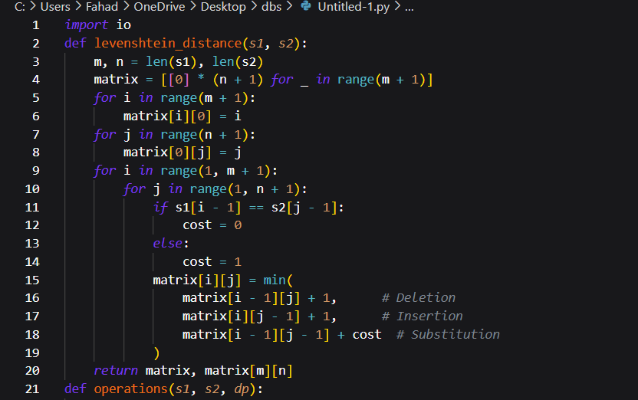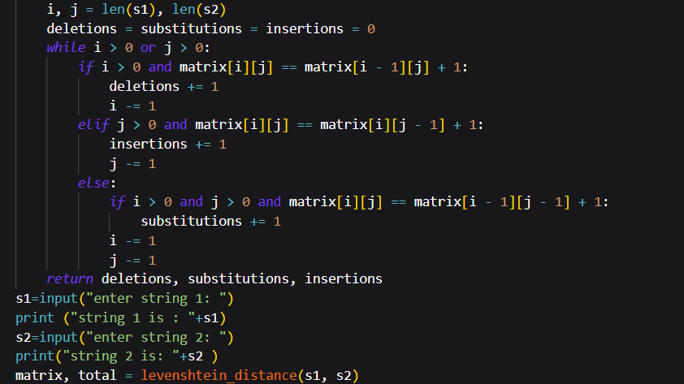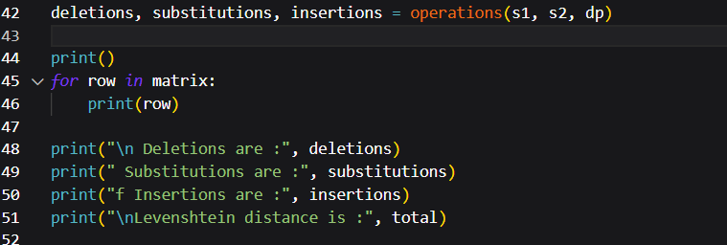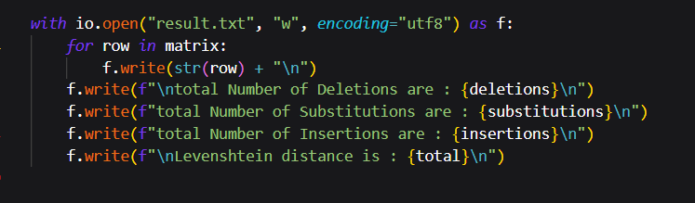

Task #2

Now modify the above written program in such a way that it takes two text files containing single- line and lowercase English sentences named as reference.txt and hypothesis.txt, and outputs the file result.txt containing Levenshtein distance of these two files as below. The distance should be word level and not character level.

**********reference.txt***************

this is some text and we would like to see if it has been identified correctly by speech recognition system

***************************************

**********hypothesis.txt*************

this is a text and we would like to check what has been identified by the speech recognition

***************************************

*********result.txt******************* Levenshtein distance is 7
Insertions 1

Deletions 3

Substitutions 3

***************************************

Hint:-

In this case we can treat words as characters in previous case, right?

REFERENCE FILE:
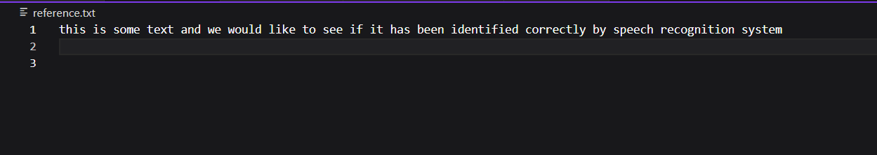

REFERENCE FILE:
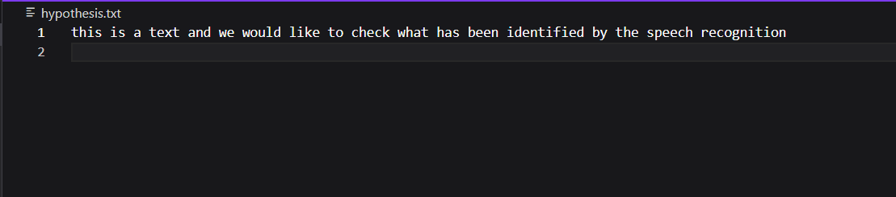

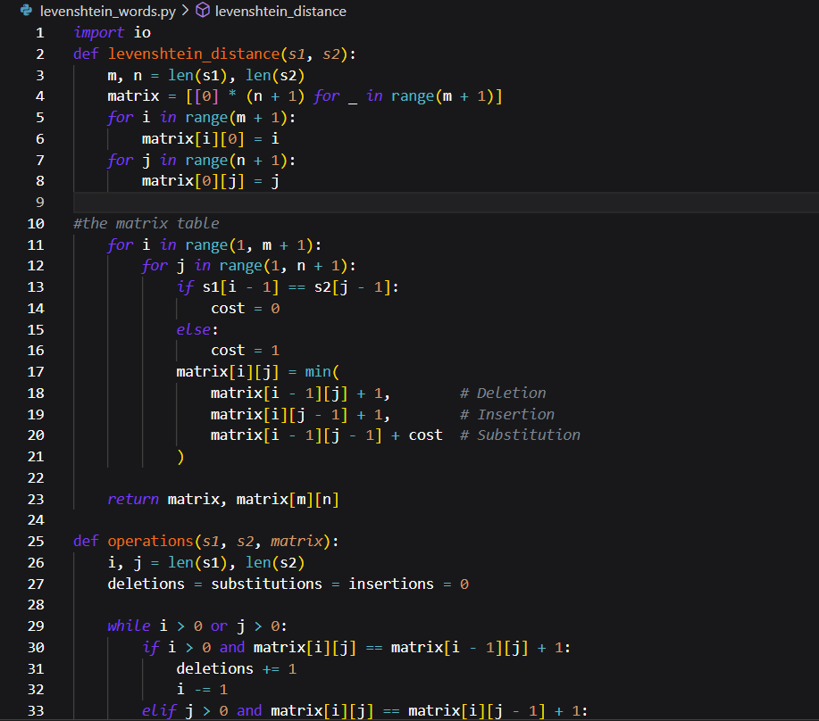

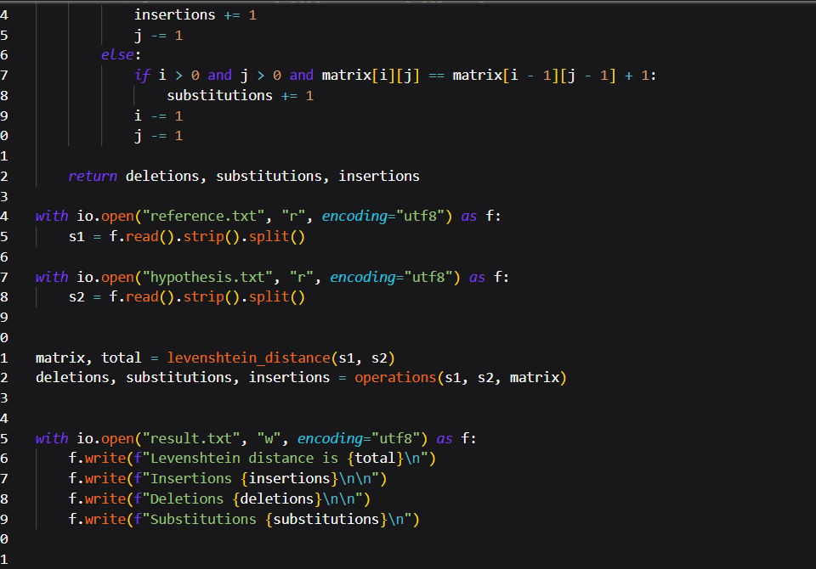

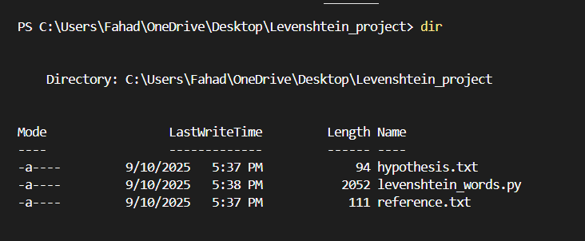

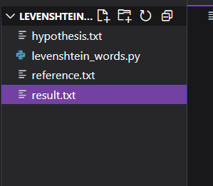

RESULT FILE:

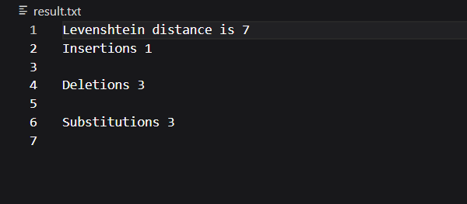

Task #3

Now modify the above program so that it ignores 10 common words in such a way:-

- Insertions and deletions involving these common words are ignored
- Substitutions are ignored when both initial and final word are one of 10 common words

List of 10 common words:

the, of, and, a, be, this, there, an, been, some Now the result2.txt should look like :-

*********result2.txt******************* Levenshtein distance is 5
Insertions 0

Deletions 3

Substitutions 2

***************************************

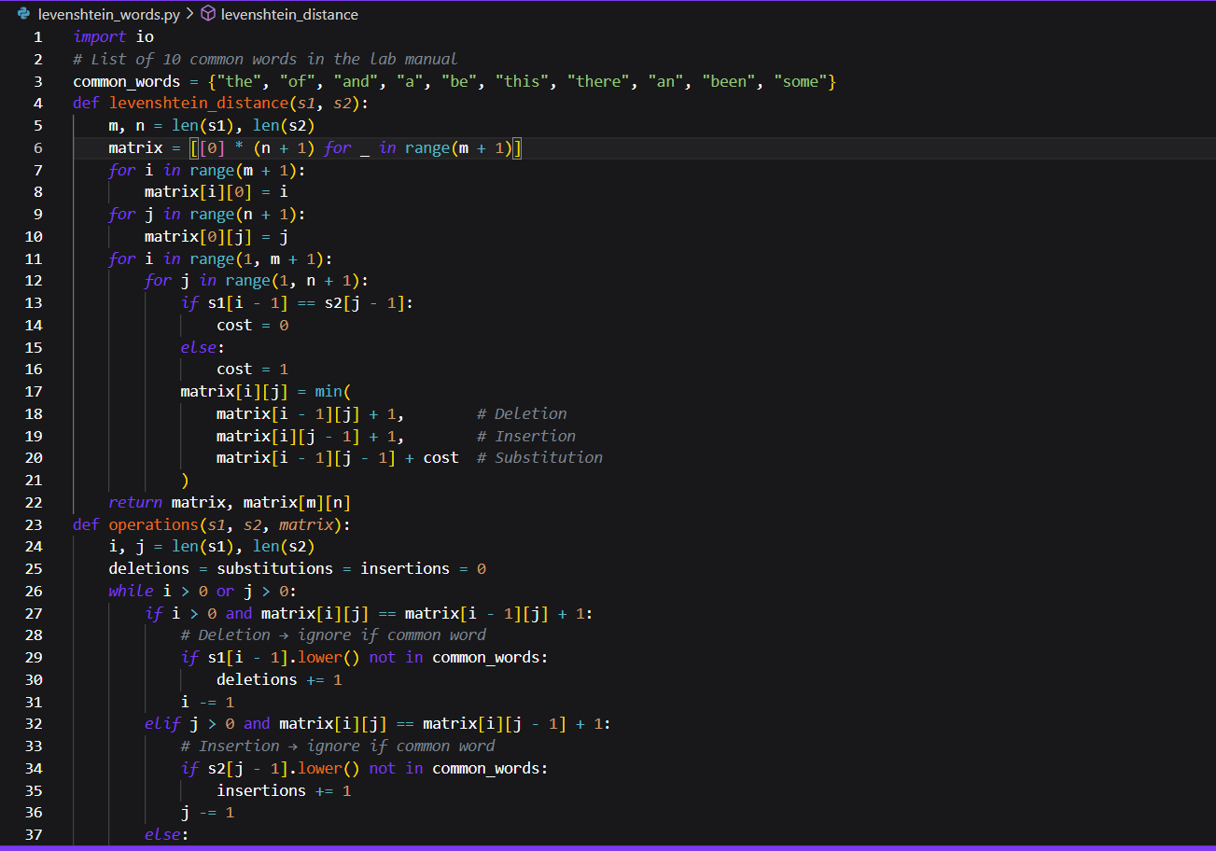

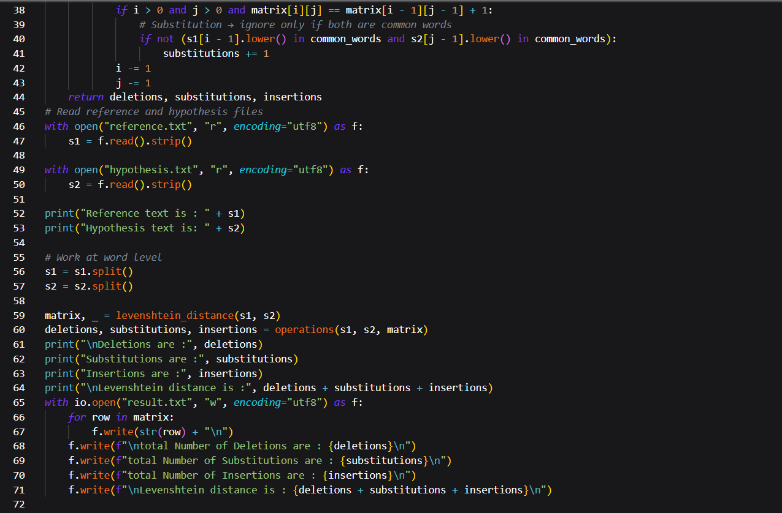
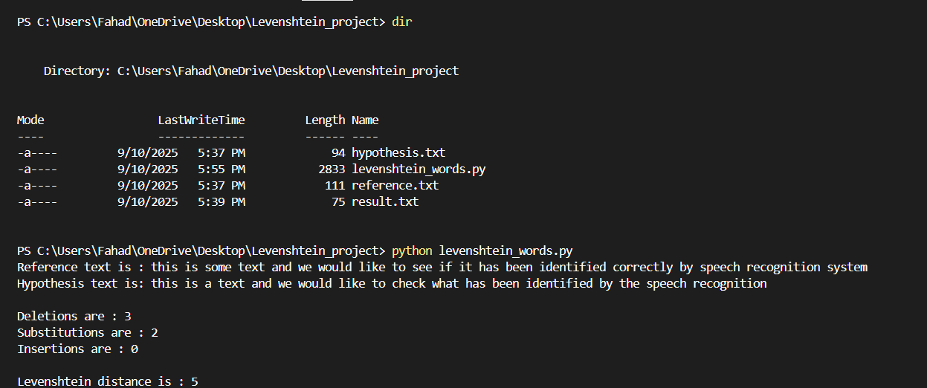

Submission Deadline: 9th Sep 2025 11:59pm via LMS only

